WEEK 2 — EXPLORATORY DATA ANALYSIS REPORT
Opportunity Dataset · Data Visualization Trainee Internship
Sign-Up Trends · Delivery Format · Scholarship Distribution · Visual Analysis · Key Findings
Data Visualization Trainee
September 2026
Author: Data Visualization Trainee (Team 11)
Target Deliverable: Week 2 Exploratory Data Analysis & Quality Audit.
Dataset Version: cleaned_opportunities.csv
Repository: https://github.com/sanskar00-debug/excelerate-data-preparation.git

Executive Summary
This report presents the Week 2 exploratory data analysis of the cleaned Opportunity dataset (5,674 opportunities, 43 columns), covering the four required analyses — posting trends, applications by location, outreach channel performance, and scholarship distribution — plus seven supplementary analyses that add further context.
Posting activity is sharply cyclical, clustering around academic intake windows (July, October/November, February/March) rather than arriving as a steady stream, pointing to scheduled administrative batch uploads. Program length is heavily templated around 210 days, and a near-universal $120 micro-scholarship functions as a standard participation token rather than a merit-based award. The platform runs on a globalized, USD-first pricing model, and the strongest statistical relationship uncovered — a moderate negative correlation (r = -0.48) between duration and reward presence — reinforces a distinct “fast, low-friction, rewarded” profile among shorter opportunity types such as Competition and Event.
Two of the four required analyses — applications by location and outreach channel performance — could not be completed as originally scoped: the dataset records opportunities, not applicants, and contains no applicant-level location or acquisition-channel field. This limitation is documented in Sections 3.2 and 3.3, with a recommended data-collection fix carried into Section 4.

1. Dataset Overview
This report analyzes the cleaned Opportunity dataset produced during Week 1, using Python for exploratory analysis and visualization. Each row represents one posted opportunity an internship, course, competition, event, career track, engagement, masterclass, or job simulation listed on the platform described by fields such as category, posting date, duration, fee, currency, scholarship award, approval protocol, and delivery format.
- Records analyzed: 5,674 opportunities across 43 columns, after Week 1 cleaning (from a raw file of 5,733 rows).
- Time span: August 8, 2022 – May 28, 2026 (a little under 4 years of posting history).
- Categories: 10 distinct opportunity types; Internship, Career, and Competition together account for just under 60% of all postings (see Table 1).
- Grain of the data — important caveat: one row = one opportunity that was posted, not one application or one applicant. This dataset cannot tell us who applied, where they applied from, or how they heard about the opportunity only what was posted, and its terms. This limits two of the four requested analyses, addressed directly in Sections 3.2 and 3.3.
Table 1. Opportunities by Category
Category | Opportunities | Share of Total
Internship | 1,565 | 27.6%
Career | 1,082 | 19.1%
Competition | 725 | 12.8%
Course | 628 | 11.1%
Event | 615 | 10.8%
Engagement | 457 | 8.1%
Masterclass | 399 | 7.0%
Job Simulation | 198 | 3.5%
Program / Xploreu | 4 | 0.1%
Table 1 — Distribution of the 5,674 opportunities across the 10 category types.

2. Summary Statistics
Key descriptive statistics across the dataset are summarized below. Where a field contained extreme outliers that were clearly test or placeholder entries (see Section 4.3), the statistic is reported after excluding them, and this is noted.
Metric | Value
Total opportunities | 5,674
Date range | Aug 2022 – May 2026
Distinct categories | 10
Currency mix | USD 82.4% · INR 6.1% · EUR 5.8% · unspecified 5.7%
Median program duration | 210 days (~7 months)
Opportunities that are free (fee = $0) | 78.9% (4,477 of 5,674)
Opportunities offering a micro-scholarship | 86.2% (4,890 of 5,674)
Median micro-scholarship award | $120 (outliers excluded)
Auto-approved applications (overall) | 14.1%
Manually reviewed applications (overall) | 85.9%
Delivery format specified as remote (WFH or Virtual) | 74.6% (4,231 of 5,674)

3. Exploratory Analysis & Visual Findings
This section walks through each required analysis sign-up trends, location, outreach channel, and scholarship distribution followed by three supplementary analyses (duration, approval workflow, and currency mix) that add useful context to the same dataset.

3.1 Opportunity Posting ("Sign-Up") Trends
A note on terminology: the dataset records when an opportunity was created/posted, not when an applicant signed up for it. Read as a proxy for sign-up trends, this is the supply side of the marketplace how actively new opportunities were made available over time.
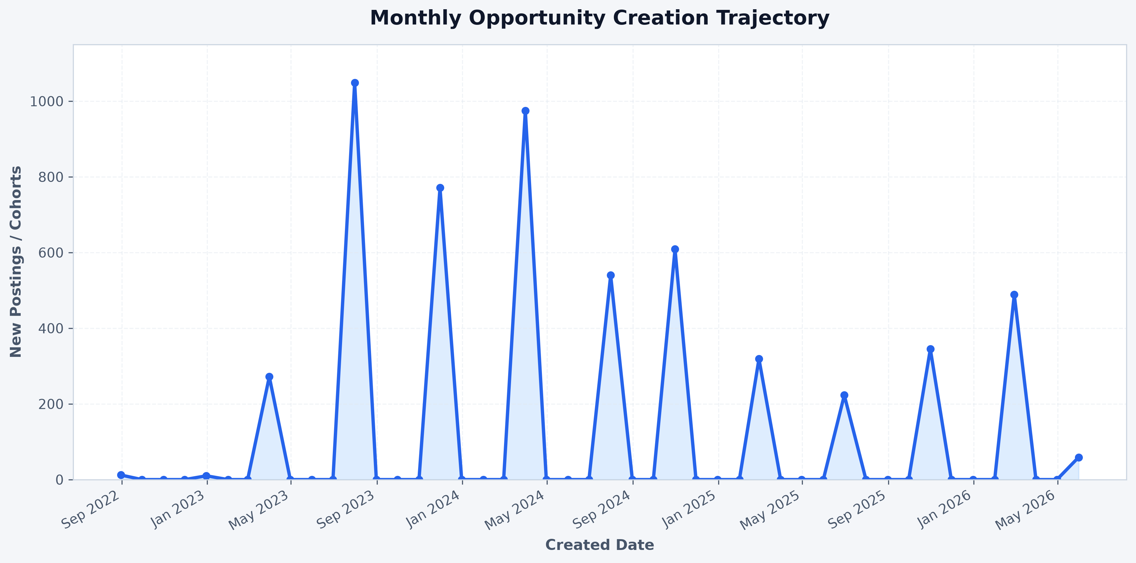
The posting history is sharply cyclical rather than steady. Eight distinct spikes are visible, each followed by a near-total drop to baseline. The three largest are July 2023 (1,049 postings), March 2024 (975), and November 2023 (771), with smaller repeat spikes in October 2024 (609), July 2024 (540), February 2026 (489), October 2025 (345), and February 2025 (319).
The recurring months clustered around July, October/November, and February/March line up closely with common academic-calendar admission windows (summer and fall intakes, and a new-year intake). This strongly suggests opportunities are uploaded in scheduled administrative batches ahead of each intake cycle, rather than posted continuously as they become available.

3.2 Applications by Location
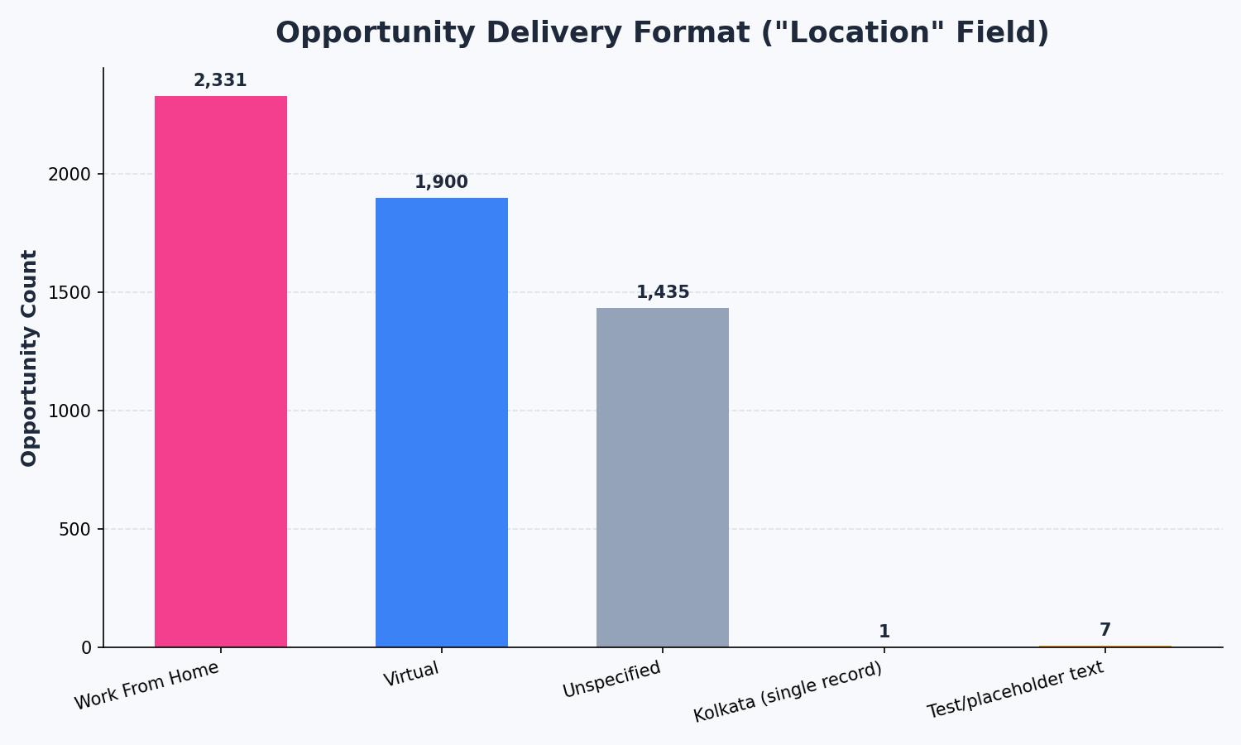
Of the 5,674 opportunities, 41.1% are tagged "Work From Home" and 33.5% "Virtual" together, 74.6% are explicitly remote. A further 25.3% leave the field blank, and 8 records contain placeholder/test text (e.g. Latin filler phrases) rather than a real value, plus a single genuine city entry (Kolkata). Because so much of the platform's activity is remote by design, applicant geography is likely wide and international but this dataset cannot confirm that without an applicant-level location field, which is recommended as a future data-collection addition (Section 4.4).

3.3 Acquisition & Channel Attribution Analysis (Data Gap Assessment)
If channel-level reporting is a requirement for this cohort's evaluation, the fastest path forward is checking whether the marketing or admissions team keeps a separate applicant-level export (e.g., a CRM or form-submission log) with a channel/source column, that is a different dataset from the one analyzed here.

3.4 Scholarship Distribution
The dataset includes a micro-scholarship award amount on every opportunity. Six records (0.1% of the dataset) carry clearly implausible values including one $500,000,000 award tied to an opportunity named "KOREY119" and a $10,000,000 award on a record named "dewf" consistent with test or placeholder entries rather than real awards. These were excluded from the statistics and chart below; the finding itself is carried forward as a data-quality note in Section 4.3.
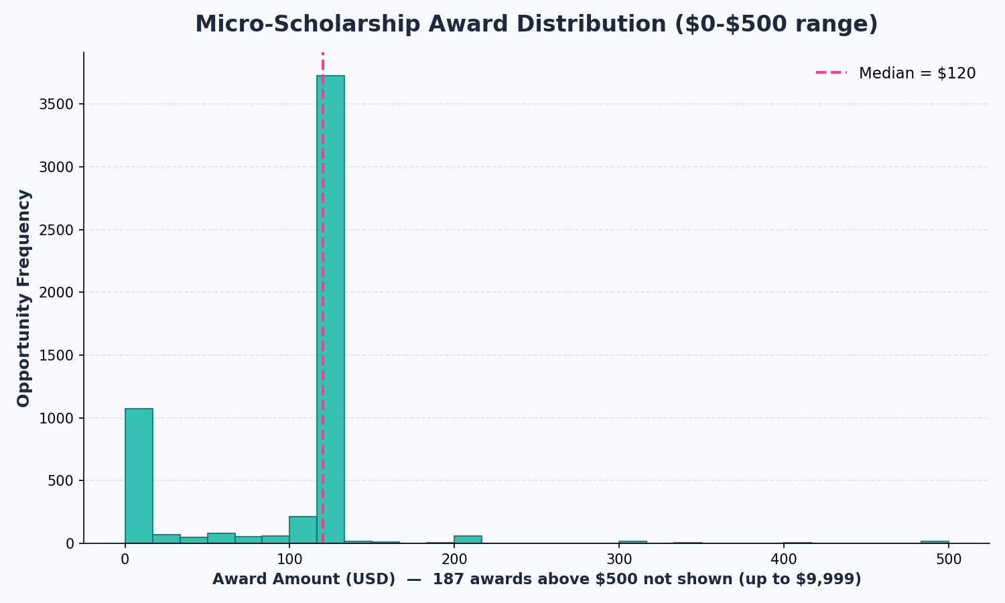
Excluding the outliers, awards cluster overwhelmingly at $120, which is both the median and the effective mode — 86.2% of opportunities carry some award, and the great majority of those sit at exactly this figure. A smaller secondary group (187 opportunities, about 3%) carries awards between roughly $300 and $9,999, but the standard $120 token dominates the picture. This points to a mostly standardized award rather than a merit- or need-based variable scholarship.
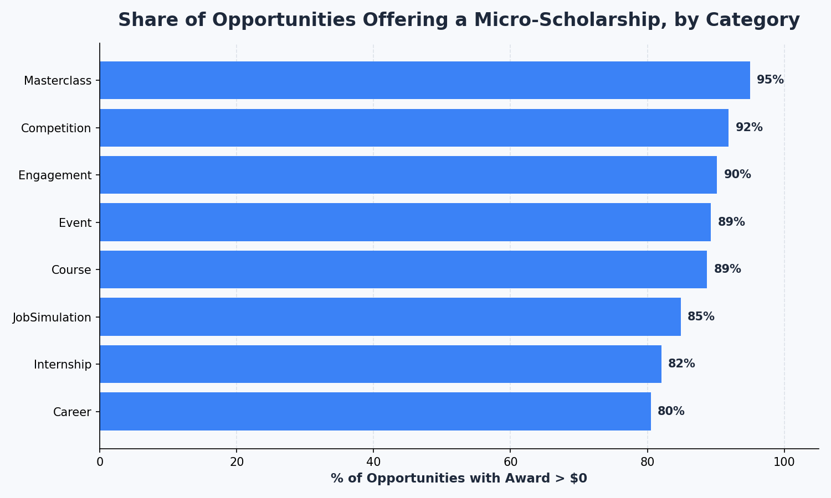
Coverage is fairly high across the board but not uniform: Masterclass (95.0%) and Competition (91.9%) opportunities are the most likely to carry an award, while Career (80.5%) and Internship (82.0%) are the least likely — a roughly 15-point gap between the highest- and lowest-covered categories.

3.5 Program Duration Distribution (Supplementary)
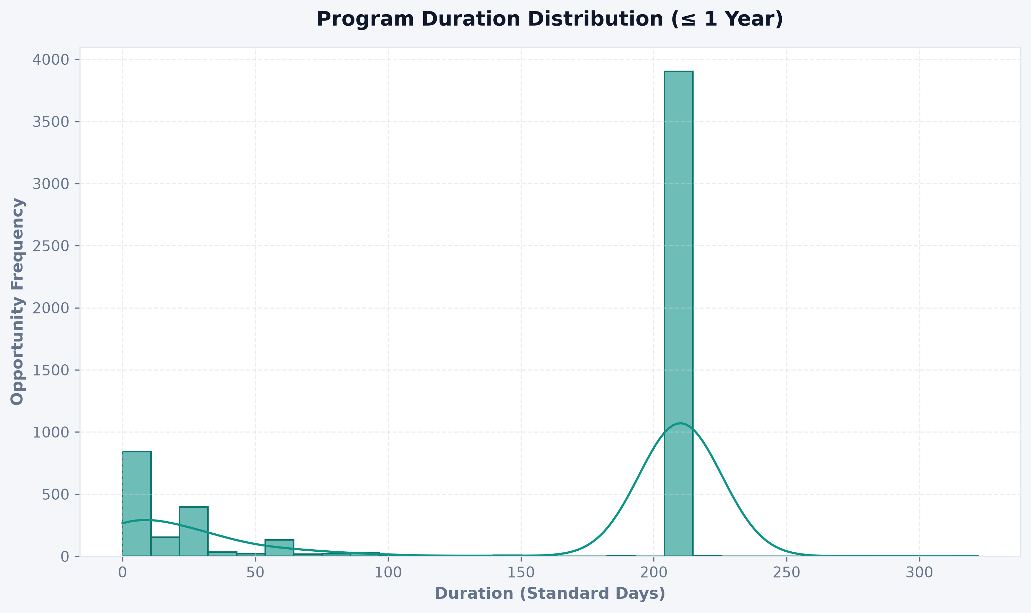
Duration is bimodal, not evenly spread. A dominant spike sits at 210 days (~7 months), with a much smaller, looser cluster under 50 days. The 210-day figure is so heavily concentrated that it looks like a default or templated program length rather than an organic mix of durations — worth confirming with whoever manages opportunity templates.

3.6 Application Approval Workflow (Supplementary)
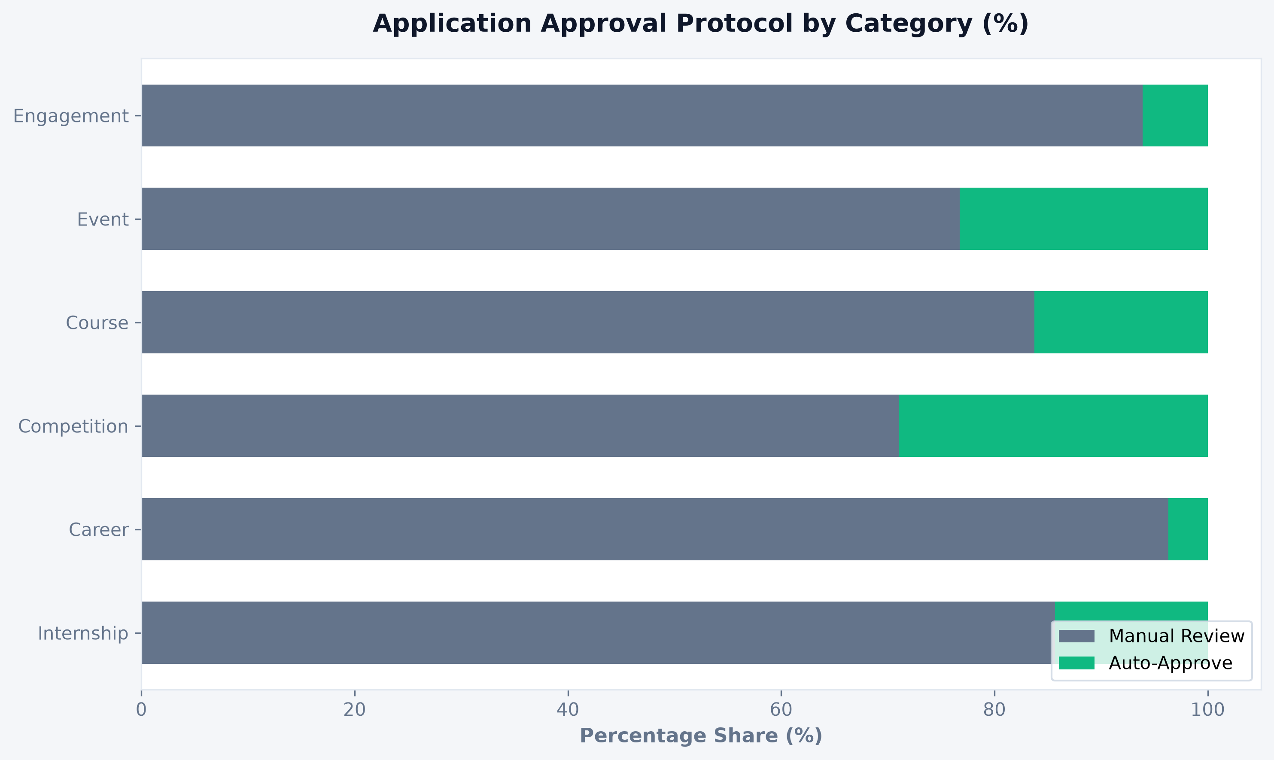
Manual review dominates overall (85.9% of applications), but the split by category is wide: Competition has by far the highest automation at 29.0% auto-approve, followed by Event (23.3%) and Course (16.2%). Career sits at the opposite extreme — only 3.7% auto-approved — with Engagement (6.1%) and Job Simulation (7.1%) similarly low. The pattern fits how each category is likely assessed: Competitions can often be scored objectively (a score, a submission, a rank), while Career and Engagement opportunities plausibly need a human judgment call on fit.

3.7 Currency / Financial Mix(Supplementary)
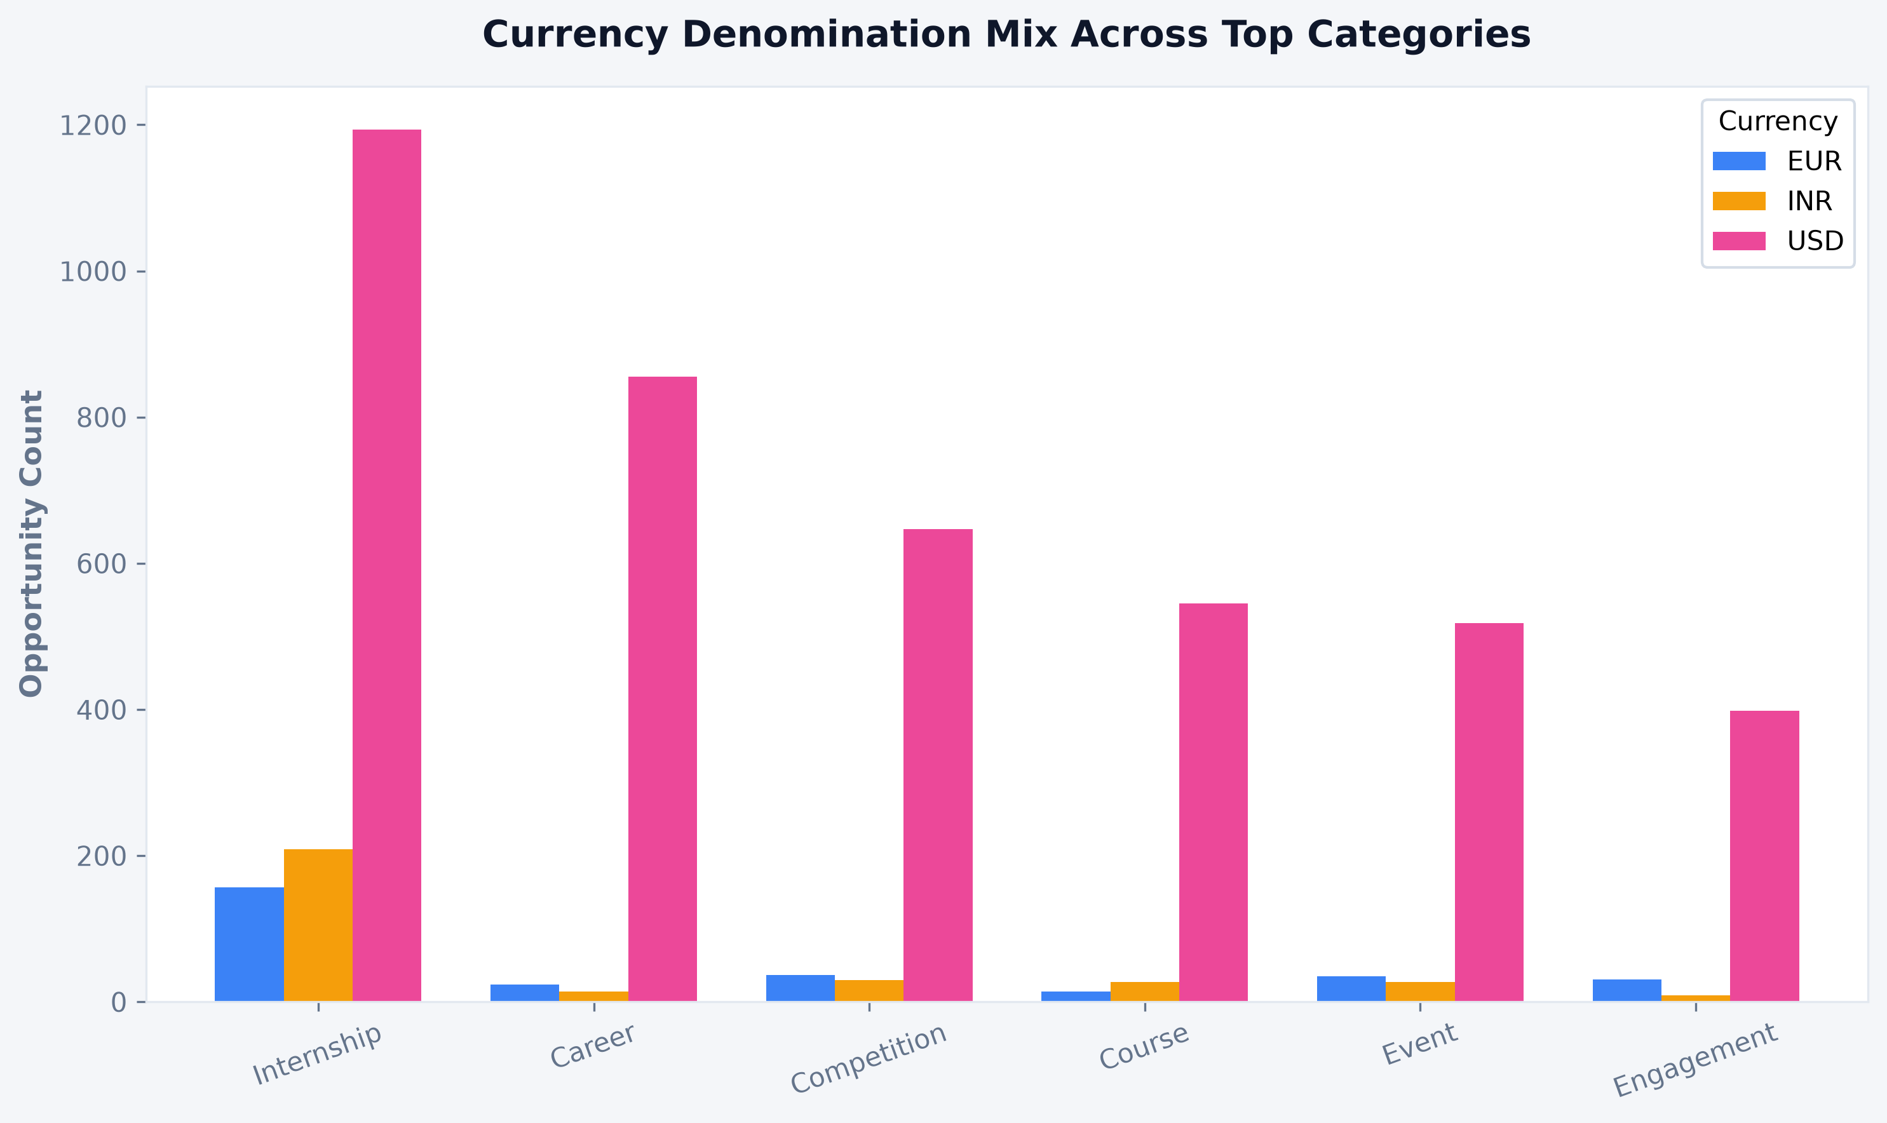
USD is the standard currency across every category (82.4% overall). Internship is the only category with a meaningful non-USD footprint: of its 1,559 currency-tagged listings, 209 are priced in INR and 157 in EUR — together about 23% of internships, versus single-digit percentages for every other category. This suggests Internship is the one product line actively localized for non-US markets, while the rest of the catalogue is priced on a single global USD baseline.

3.8 Feature & Add-On Adoption (Supplementary)
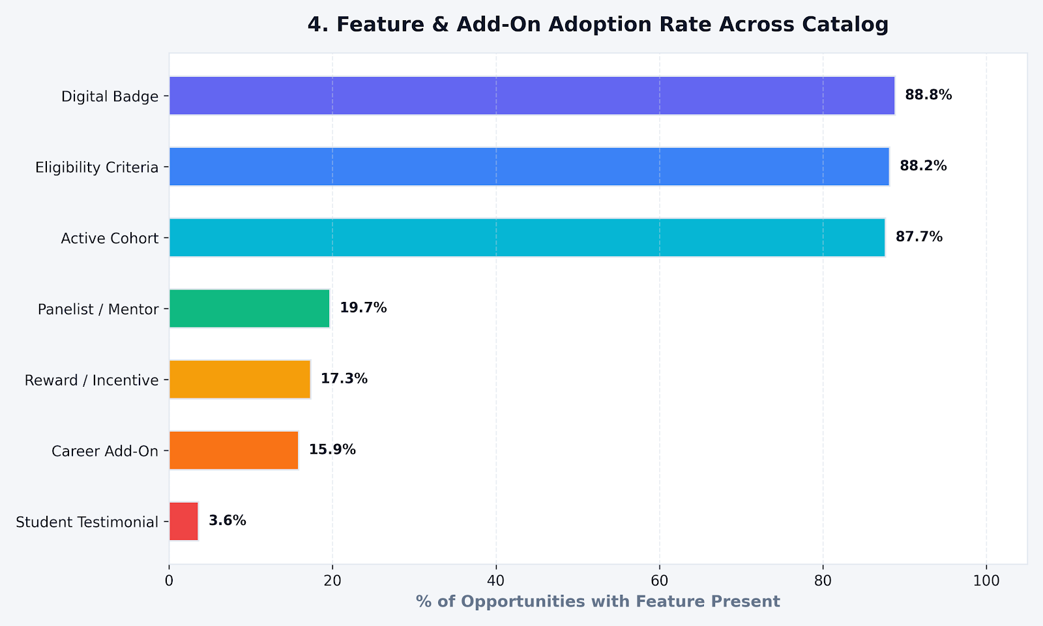
Three features are near-universal across the catalog — Digital Badge (88.8%), Eligibility Criteria (88.2%), and Active Cohort (87.7%) — while four others are comparatively rare: Panelist/Mentor (19.7%), Reward/Incentive (17.3%), Career Add-On (15.9%), and Student Testimonial (3.6%). This points to a clear two-tier structure: a standard set of features attached to nearly every opportunity, and a smaller set of enrichment features reserved for a minority of listings — likely the more involved or higher-profile ones (competitions, masterclasses).

3.9 Monetization Model: Free vs. Paid Access (Supplementary)
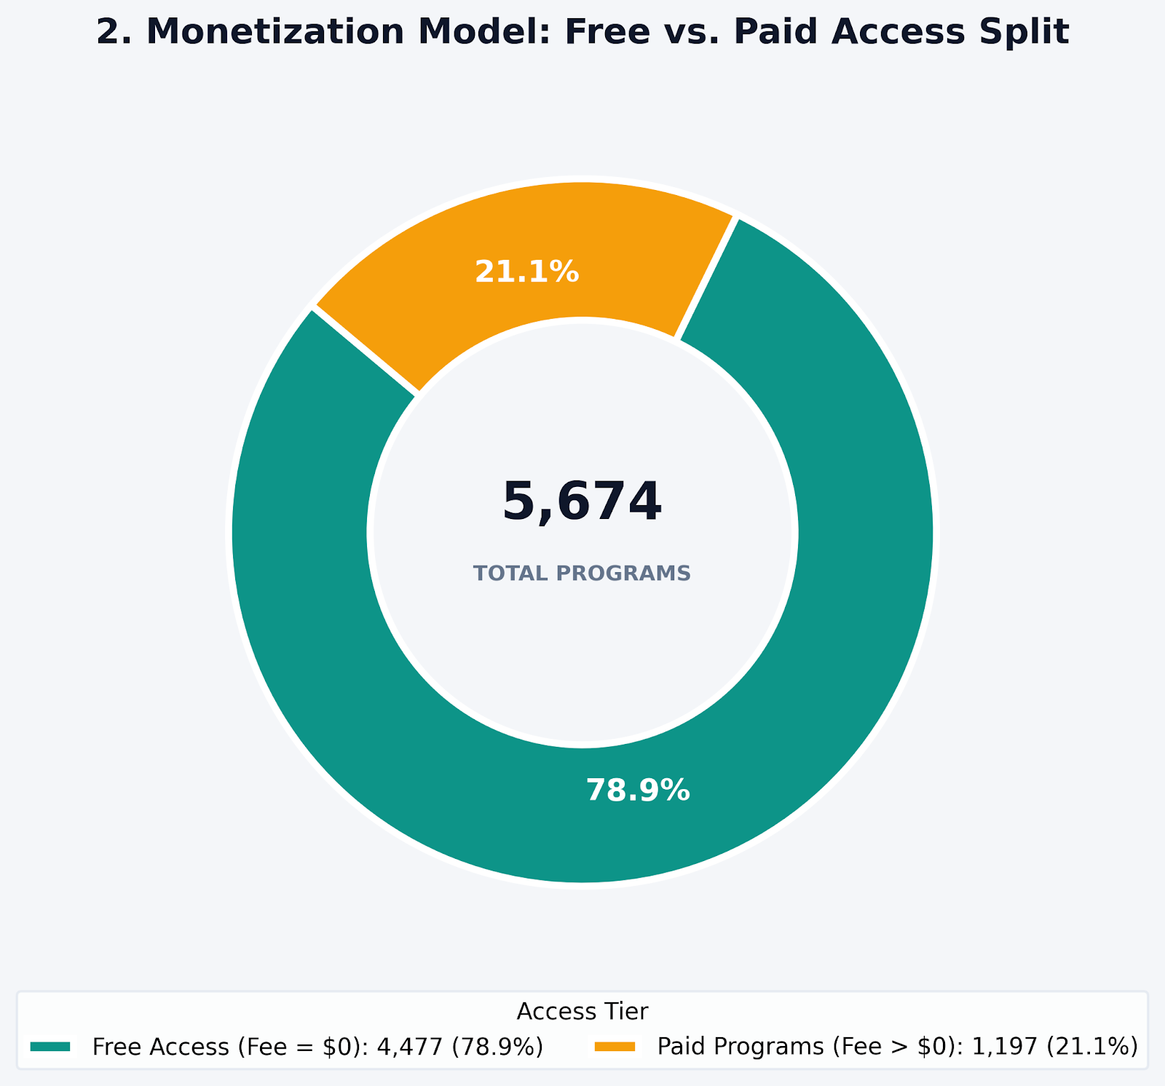
Of the 5,674 opportunities, 78.9% (4,477) are free to access (fee = $0), while 21.1% (1,197) carry a fee. This confirms the platform is overwhelmingly a free-access model, with paid opportunities as the minority case consistent with the near-universal micro-scholarship coverage noted in Section 3.4, which further lowers the effective cost of participation for most listings.

3.10 Duration Measurement Units, Pre-Standardization (Supplementary)
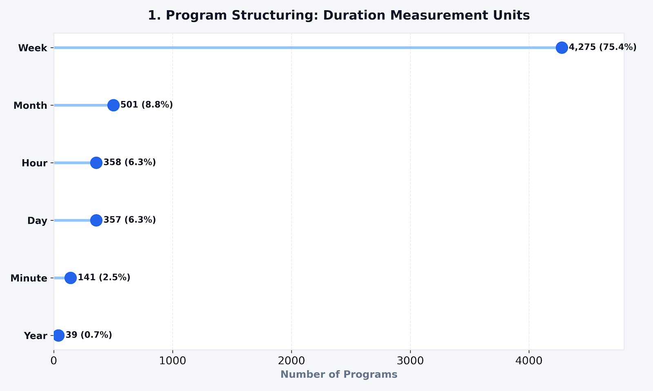
Before conversion to standardized days (Section 3.5), durations were recorded in six different units. Week is by far the dominant unit (4,275 opportunities, 75.4%), followed by Month (8.8%), Hour (6.3%), and Day (6.3%), with Minute (2.5%) and Year (0.7%) far less common. This confirms that the 210-day spike identified in Figure 5 is driven almost entirely by week-denominated listings, rather than being an artifact of the unit-conversion process.

3.11 Feature & Metric Correlation (Supplementary)
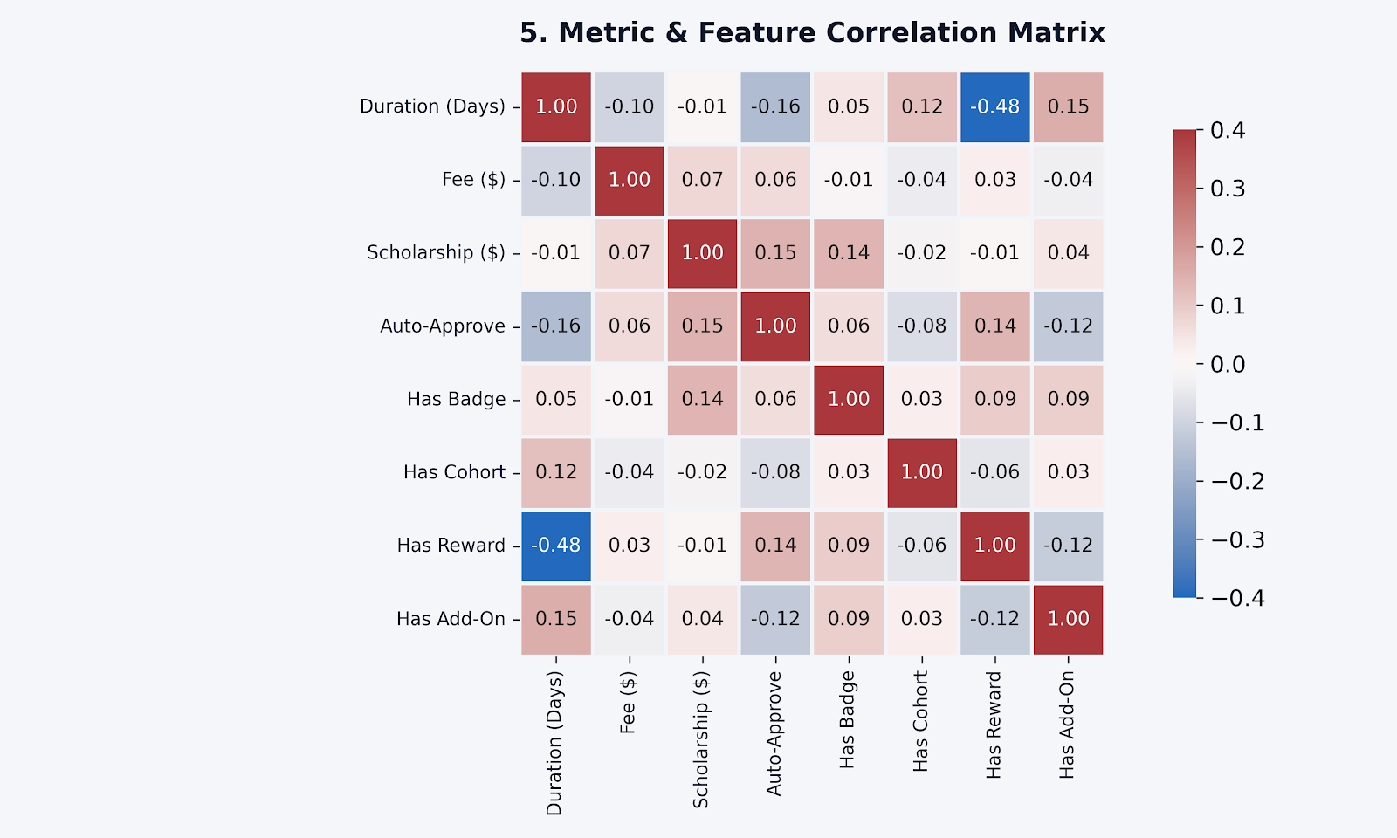
Most relationships in the dataset are weak, but one stands out: Duration (days) correlates negatively with Has Reward at -0.48 the strongest relationship in the matrix meaning shorter opportunities are noticeably more likely to carry a reward than longer ones. Auto-Approve also correlates negatively with Duration (-0.16), consistent with the pattern in Section 3.6 where faster, lower-friction categories (Competition, Event) lean toward both shorter formats and automatic approval. No other pairing exceeds ±0.16 in magnitude, indicating these two relationships are the only meaningfully structured ones among the eight variables tested.

4. Actionable Strategic Recommendations

4.1 Major Trends
- Opportunity postings follow a sharp seasonal cycle tied to academic intake windows (July, October/November, February/March), rather than a steady drip administrators appear to batch-upload cohorts ahead of each intake.
- Program length clusters overwhelmingly around 210 days (~7 months), suggesting a dominant template rather than organically varied program lengths.
- A near-universal $120 micro-scholarship is attached to most opportunities (86.2%), functioning more like a standard participation token than a merit-based award.
- The platform runs on a globalized, USD-first financial model, with Internship as the only category showing meaningful multi-currency (INR/EUR) pricing.

4.2 Patterns & Relationships
- Categories that lean on human judgment for admission (Career, Engagement) also show the lowest scholarship coverage and the lowest auto-approval rates consistent with a more gatekept, individually-assessed application experience.
- Competition is the outlier in the opposite direction: highest auto-approval (29.0%) and high scholarship coverage (91.9%), consistent with objectively scored, low-friction entry.
- Roughly three-quarters of opportunities are explicitly remote (Work From Home or Virtual), which combined with the missing applicant-location data points to a likely global, geographically dispersed applicant base that the current data cannot confirm directly.
- The only strong quantitative relationship in the correlation matrix (Section 3.11) is between Duration and Has Reward (r = -0.48): shorter opportunities are more likely to carry a reward, reinforcing the low-friction, quick-turnaround profile seen in Competition and Event categories.

4.3 Noteworthy Observations (Data Quality)
- Six micro-scholarship records (up to $500,000,000) and extreme values in the fee field (up to several trillion) are almost certainly test/placeholder entries and should be excluded from any production reporting until confirmed with the platform team.
- The duration_type field contains inconsistent and malformed entries (singular/plural mixes, and typos such as "yearssss" and "da"), which inflates duration statistics unless standardized first.
- Roughly 17% of records have a blank delivery-format field and 5.7% have no currency recorded both worth flagging to whoever owns data entry for these listings.

4.4 Areas for Future Investigation
- Applicant-level location and outreach-channel data do not exist in the current dataset. Recommend the team start logging country/city and acquisition channel (referral, social, email, etc.) per application in future cohorts so these two required analyses can be produced directly rather than proxied.
- The three largest posting spikes (Jul 2023, Mar 2024, Nov 2023) are worth a closer look to confirm whether they reflect genuine demand surges or bulk administrative imports, the pattern is too uniform to assume it's organic without checking.
- Worth confirming with the platform/data team whether the 210-day duration spike is a hard-coded template default, since it affects any duration-based planning built on this dataset.

